Schematics

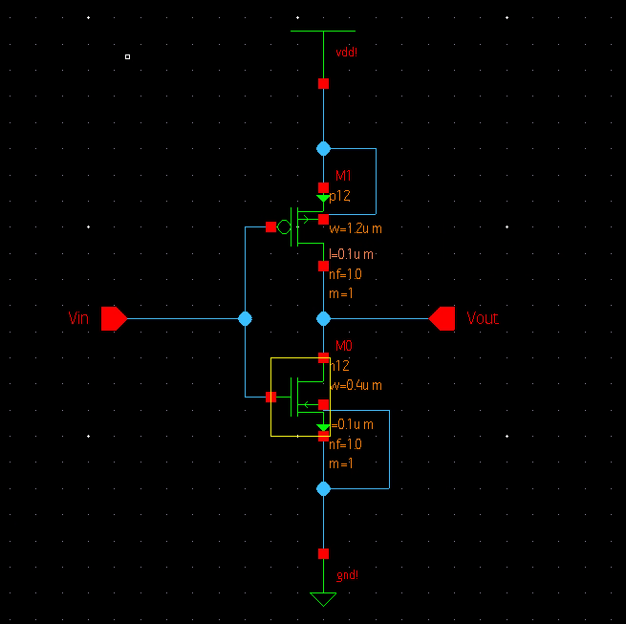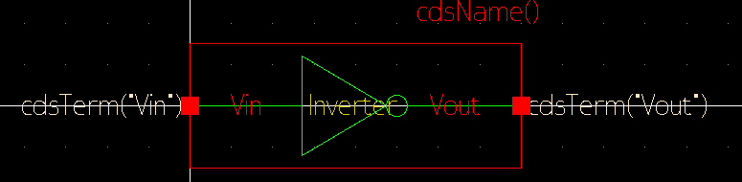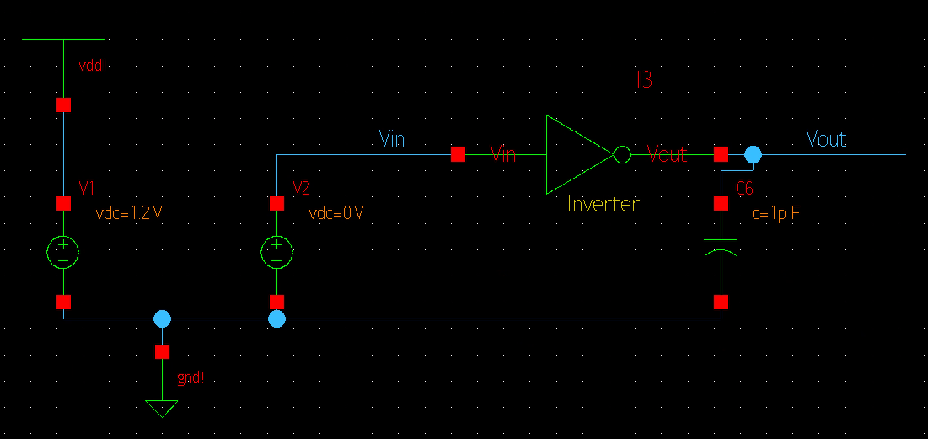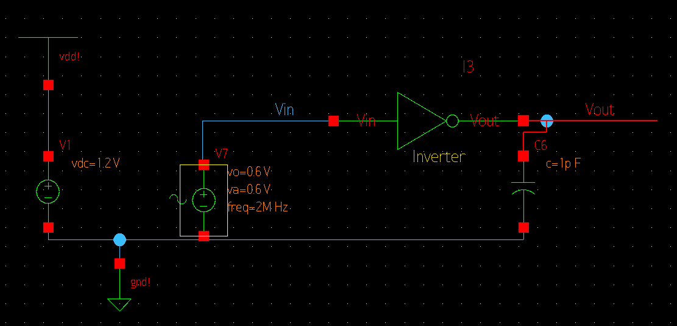

SAE Setups

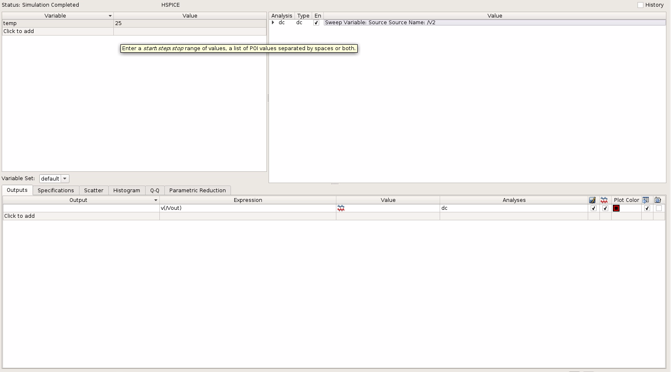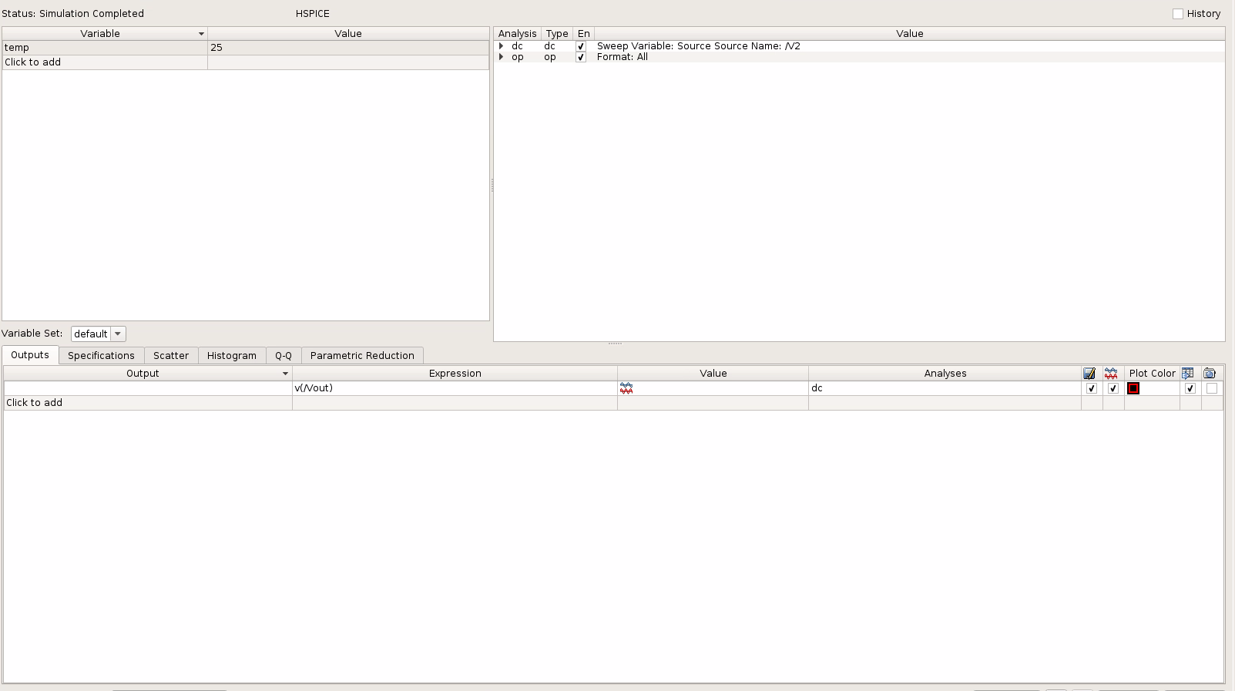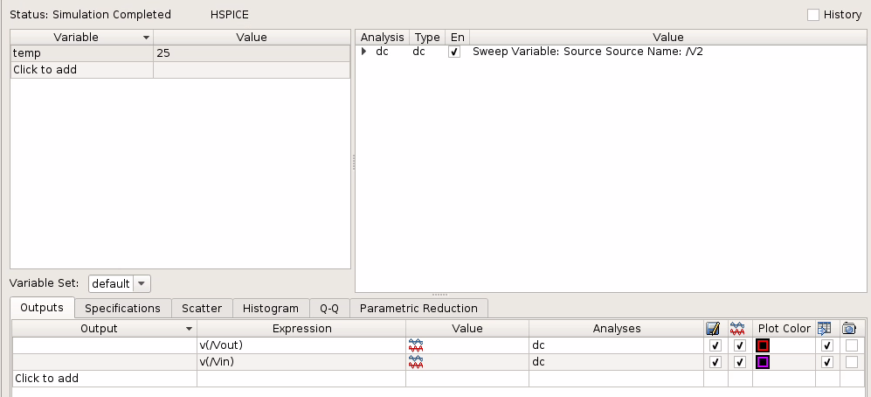

Waveforms

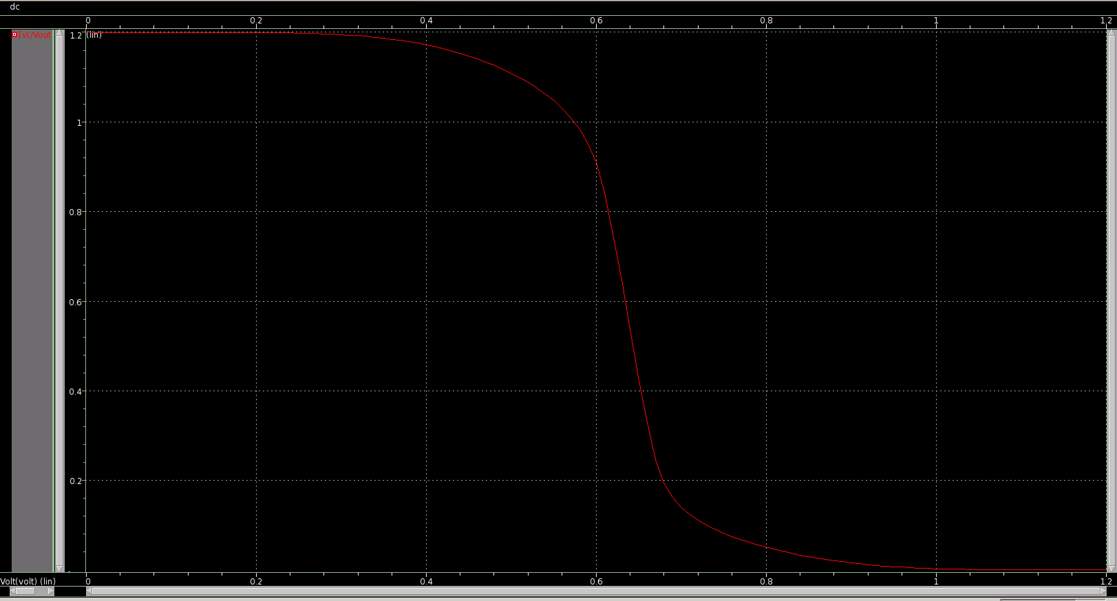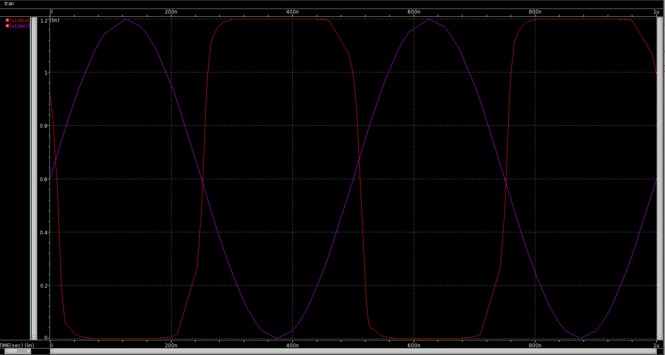

Derivatives

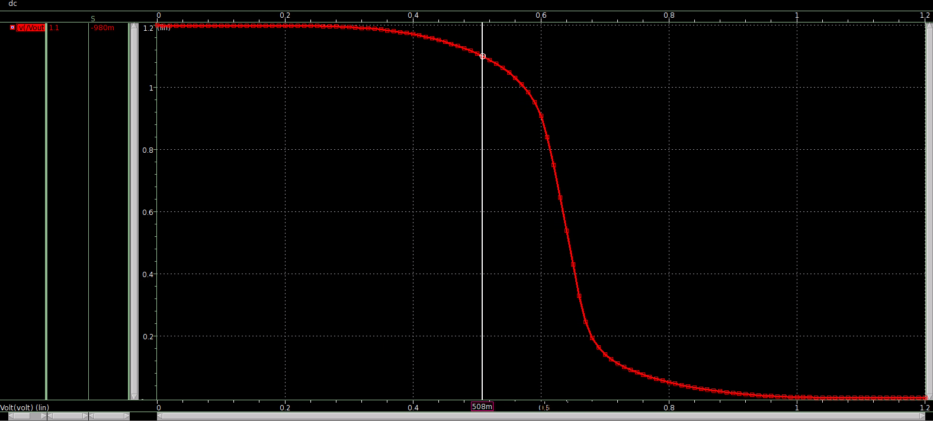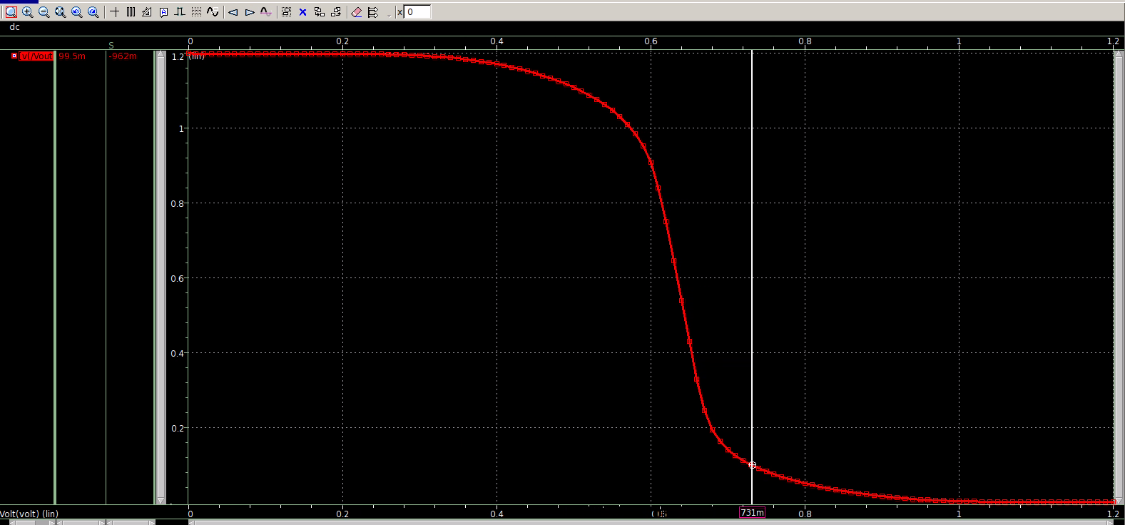

Vm

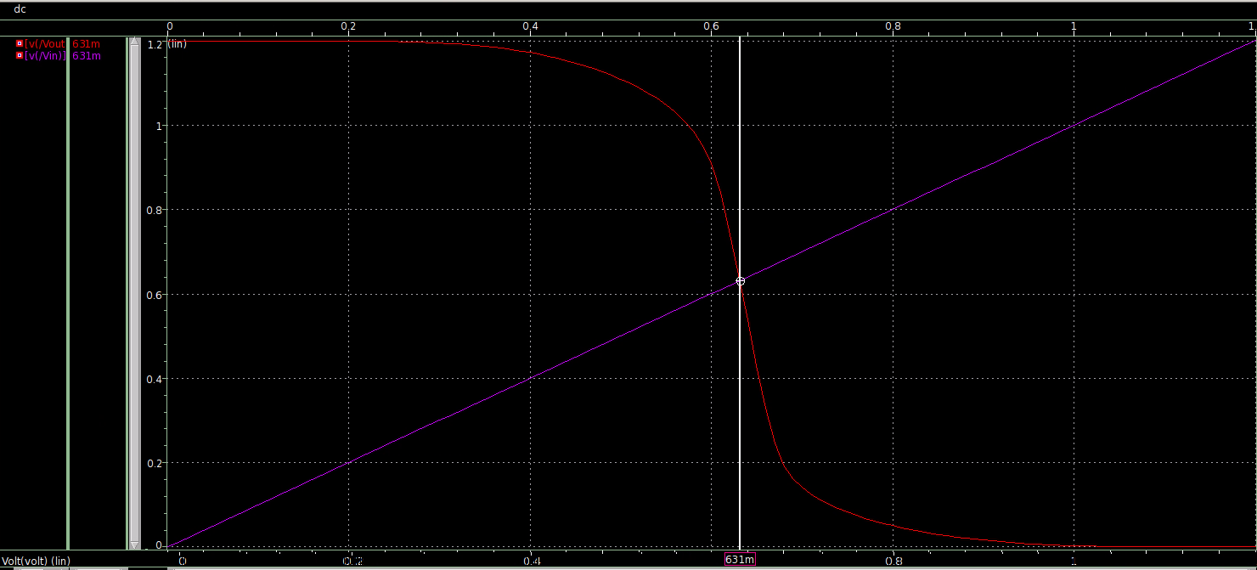

Voh and Vil

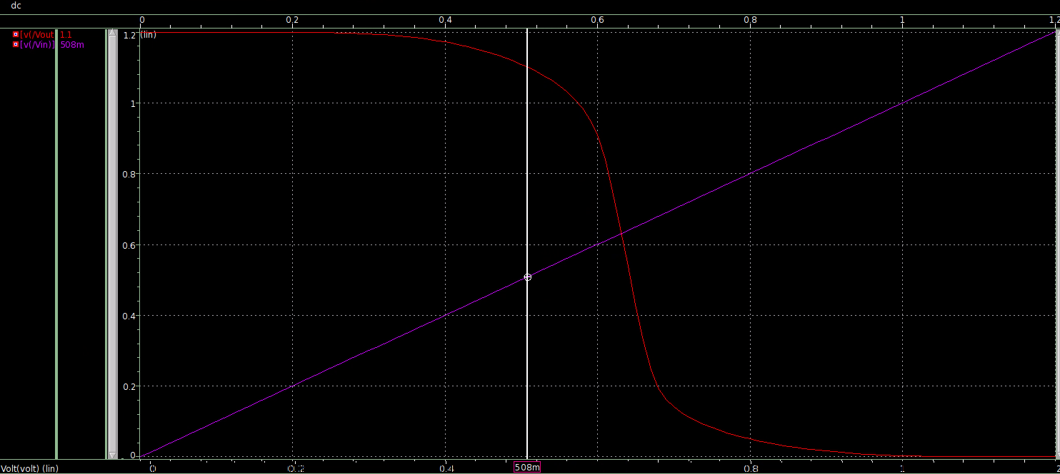

Vol and Vih

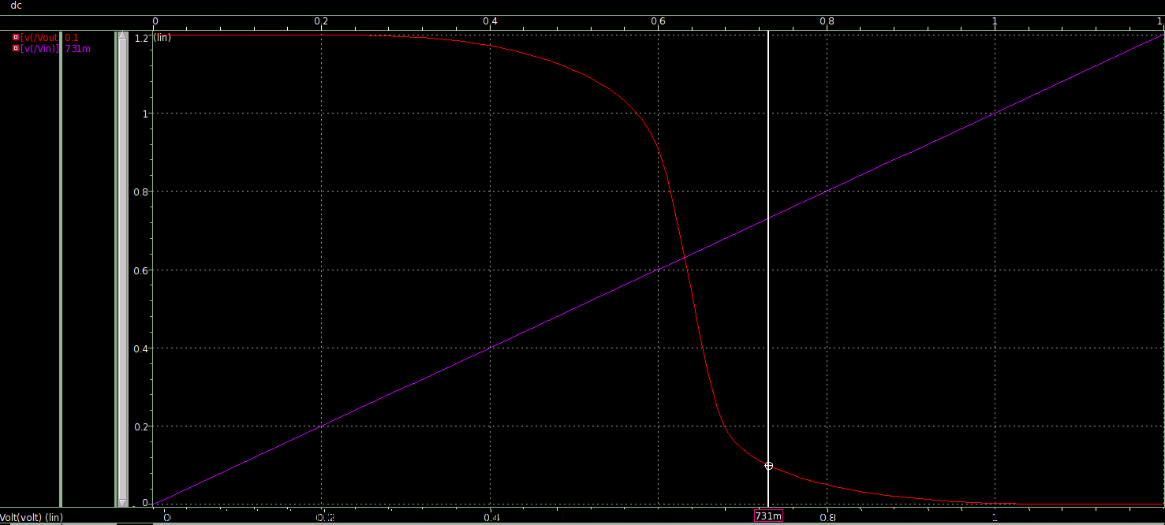

OP Analysis



Questions

The width of the NMOS is 0.4um. The width of the PMOS is 1.2um.

Vm = 631mV

Vih = 731 mV

Vil = 508 mV

Voh = 1.1 V

Vol = 0.1 V

Conclusion

When Vin = Vout, that’s what Vm is equal to. Vih, Vil, Voh and Vol can all be found when the slope of Vout is -1.